|  |  |  |  |  |  |  |  |  |
| --- | --- | --- | --- | --- | --- | --- | --- | --- |
| **Whole School.jpg** |  |  |  |  |  |  |  |  |
|  |  |  |  |  |  |  |  |  |
|  |  |  |  |  |  |  |  |  |
|  |  |  |  |  |  |  |  |  |
|  |  |  |  |  |  |  |  |  |
|  |  |  |  |  |  |  |  |  |
|  |  |  |  |  |  |  |  |  |
|  |  |  |  |  |  |  |  |  |
|  |  |  |  |  |  |  | **large_green_logo.bmp** |  |

|  |  |  |
| --- | --- | --- |
| NSW Department of Education & Training |  | 3270 |
|  | | |
| 2010 Annual School Report | | |
| Tullamore Central School | | |
| NSW Public Schools – Leading the way | | |



Our school at a glance

Students

There were 85 students, with 58 students in K–6 and 27 students in Years 7 – 12.

The Western Access Program (WAP) catered for 7 students in Years 11 and 12 with the 3 students in Year 12 gaining their Higher School Certificate (HSC).

Our Kindergarten class had 12 students enrolled.

All students at Tullamore Central School participated in our whole school sporting events; the swimming, athletics and crosscountry carnivals.

Several students were selected to compete at higher representative levels with Jake Newman attending the CHS Athletics in Homebush, Sydney for the Under 15 Discus.

Students also had the opportunity to represent the school in the Premier’s Reading Challenge, Spelling Bee and Debating. Harry Patton represented Western Region at the State Primary Debating Competition in Sydney.

Our school captains were involved in leadership opportunities. These included:

* Meeting Her Excellency Professor Marie Bashir, AC CVO, Governor of New South Wales at Government House
* Attending and speaking at the Anzac Memorial Service, school assemblies, speech night and the school concert.

The WAP presentation night included academic awards to Breanna Horsburgh for PDHPE and General Mathematics, Isaac Dengate for General Mathematics, and Valeena Fidock for Advanced English and Mathematics.

Staff

Tullamore Central School has 21 full-time and part-time staff who work tirelessly and take on extra curricula responsibilities to provide students with a wide range of opportunities that enhance the well-being of all our students.

All teaching staff meet the professional requirements for teaching in NSW public schools.

Significant programs and initiatives

Tullamore Central School staff and students were involved in the following significant programs and initiatives to support the teaching and learning programs that have been developed to enhance student achievement of learning outcomes; National Partnerships Low SES, Country Areas Program (CAP), Positive Behaviour for Learning (PBL), Western Access Program (WAP), Connected Learning, Aboriginal Education, Multicultural Education and Respect and Responsibility.

Student achievement in 2010

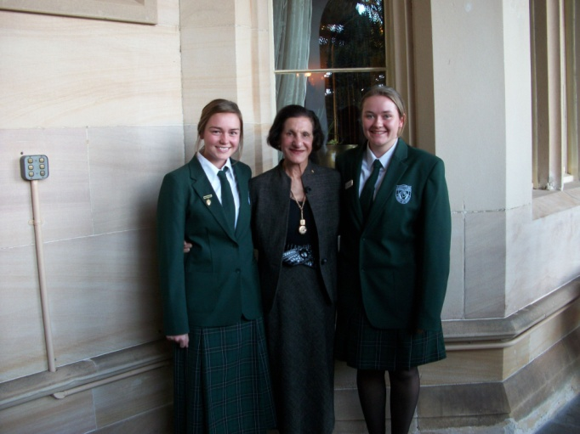All students in Years 3, 5, 7 and 9 sat the NAPLAN tests. All our students in Years 5, 7 and 9 showed growth from their previous tests. Our Year 8 students sat the ESSA test. Three students sat the School Certificate exams and were awarded a School Certificate. Also three Year 12 students sat the Higher School Certificate exams and all were awarded a Higher School Certificate.

Messages

Principal’s message

Tullamore Central School is a small isolated rural K-12 school that is staffed by both experienced and early career teachers and is supported by an active P&C. The school staff has undergone major change with an all new executive being appointed in 2010, and only four of the twelve teachers having been at the school in 2009.

Due to an increase in primary student numbers there were three composite classes in 2010.

Tullamore Central School has been granted extra funding through both the Low SES National Partnerships program and the Country Area Program (CAP). Both these initiatives have given our school extra funding to support our staff and students to achieve their potential through technology integration into the teaching and learning programs, to broaden the experiences of our students through the creative and performing arts at our school and through diverse excursions.

This year we have revitalised our Positive Behaviour for Learning (PBL) journey with staff being trained, a committee formed and lessons under development for delivery in 2011.

Students have the opportunity to represent the school both individually and as a member of a team. This year we have had students representing our school at regional level in sport, creative and performing arts, debating and spelling! We have had two students travel to state championships and competitions. An active SRC provides leadership opportunities for students.

Our school captains, Breanna Horsburgh and Valeena Fidock have represented our school with pride and dedication. They are outstanding role models for our younger students as they are always appropriately attired, speak exceptionally well at official functions, are respectful, responsible, cooperative and honest learners and are reliable citizens of both our school and community. I have also been impressed by our primary captains, Joshua Jones and Emily Walker, who have been called upon to thank guests in our school. I was very moved by Joshua’s heartfelt speech on ANZAC day.

Tullamore Central School has an important focus within the community through our school community newsletter and student and staff involvement in community events such as the Irish Festival, ANZAC service and Agricultural Show. The school has extensive grounds, excellent technology facilities and a new Trade Training Centre was to commence construction in 2010. The school has a very strong sense of community.

It is extremely rewarding to be part of a school and its community where the students wear the uniform with pride, are actively involved in all aspects of school life and genuinely care for each other and their community. I look forward to many happy years at Tullamore Central School and to meeting the challenges that lie ahead.

I certify that the information in this report is the result of a rigorous school self-evaluation process and is a balanced and genuine account of the school’s achievements and areas for development.

Sandra Carter

P & C message

At the P&C Annual General Meeting (AGM) in March this year Diane Darcy was re-elected as secretary, Carrol Bolam as treasurer and I took over as president from Cindy Larkings who retired after three successful years at the helm.

It seems like a long time ago, Mr Garry Wykes was our school principal for the first term and the school was yet to meet our new principal Mrs Sandra Carter.

Our two main fundraising events for the year were firstly the Variety Brats Bash, which is a group of altruistic car rally drivers who chose to come through Tullamore. We catered for about 60 people and organised activities for the children who were travelling with the Bash.

Secondly was Robert Gill’s clearing sale, which was a big one and required as many helpers as we could find. We offered a comprehensive menu which received the thumbs up from the many clearing sale dining connoisseurs.

These and other fundraising events have allowed the P & C to purchase two sets of football/sports guernseys for the school and also the portable shade with the school logo that you see at our sporting events.

The appointment of Mrs Sandra Carter in yerm two as our first permanent principal for a number of years brought to a head a problem we had in Tullamore with teacher housing. The principal’s residence was deemed uninhabitable and the other teacher houses and flats needed a lot of maintenance which just hadn't been done.

The P & C believes happy teachers are good teachers and we have campaigned all year to bring our teachers’ accommodation up to a suitable standard and put in processes to keep them maintained that way.

We have had some success with the Principal’s house being refurbished, maintenance has been carried out on the flats, and the Haylock Street residence is due to be attended to at the start of next year.

Getting this work done has required reams of paperwork to and from teacher housing by our hard working secretary, Diane Darcy and on behalf of the teachers and the P&C, I would like to thank her for it.

I would also like to congratulate the teachers and staff for a successful year at our school. Our students have been provided with plenty of opportunities, academic, sporting and musically and one only has to glance through a school newsletter to see how busy the school is.

Our P&C meetings are on the first Tuesday of every month in the school library. They start at 7:00pm and finish at 9:00pm.

**Bruce Jones**

**P & C President**

**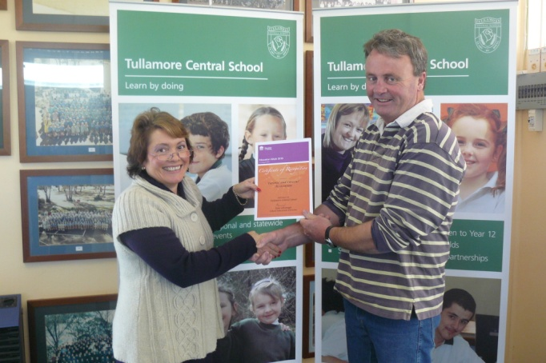**

Student representative’s message

Our Student Representative Council (SRC) is comprised of an elected representative from each class, Kinder to Year 12 and our school captains.

The SRC committee regularly meets to discuss important issues in our school community, as well as discuss fundraising events for both the school and charities.

During 2010, the SRC was involved in many activities. Some of these were:

* Golden Circle School Fundraiser
* Catering for the school athletics carnival
* Charity Fundraiser for Loud Shirt and Stewart House Day
* Secondary 4T’s Combined Social
* Charity Fundraiser for Pakistan Flood Victims
* Selling of hot chocolates and milos in term 2 and 3.

Some of our members also represented the school at community events such as:

* Irish Festival
* Anzac Day
* Variety Club Car Rally

Overall it was a successful year with the SRC fundraising total sitting at $471.68. This money will be used to purchase fruit trees to provide us with fresh fruit for our fruit breaks in the future, as well as fund any other purchases which the SRC committee sees necessary.

Thank you to all our enthusiastic and involved SRC members for 2010.

School context

Student information

It is a requirement that the reporting of information for all students must be consistent with privacy and personal information policies.

Student enrolment profile

Primary



Secondary



Student attendance profile

Primary



**Secondary**



Management of non-attendance

Class rolls are marked daily and absences recorded. Parents/care providers are notified initially by letter then by phone and or meeting. Personal Attendance Plans are negotiated for unacceptable absenteeism and if necessary referrals to the Home School Liaison Officer (HSLO).

Class sizes

In March 2003 the Government announced its commitment to publish primary class sizes in annual school reports in order to provide parents with as much local information as possible.

The following table shows our class sizes as reported at the 2010 class size audit conducted on Wednesday 17 March 2010.

|  |  |  |  |
| --- | --- | --- | --- |
| **Roll Class** | **Year** | **Total** | **Total** |
| KINDER/YEAR1 | K | 12 | 19 |
| KINDER/YEAR1 | 1 | 7 | 19 |
| YEAR 2/3 | 2 | 11 | 18 |
| YEAR 2/3 | 3 | 7 | 18 |
| YEAR 4/5/6 | 4 | 6 | 21 |
| YEAR 4/5/6 | 5 | 7 | 21 |
| YEAR 4/5/6 | 6 | 8 | 21 |

Structure of classes

There were 3 primary classes comprising K/1, 2/3 and 4/5/6.

There were 2 secondary classes: 7/8 and 9/10.

Year 11 and 12 students studied through the WAP program.

Mathematics was taught in stage classes from K – 10.

Retention to Year 12



Post-school destinations

Three students completed their HSC in 2010. Two students applied for and gained acceptance to university. The other student went to employment.

Year 12 students undertaking vocational or trade training

No students in Year 12 were involved in vocational or trade training courses

Year 12 students attaining HSC or equivalent vocational educational qualification

All Year 12 students, 100%, attained a HSC in 2010.

Staff information

It is a requirement that the reporting of information for all staff must be consistent with privacy and personal information policies.

Staff establishment

|  |  |
| --- | --- |
| Position | Number |
| **Principal** | 1 |
| **Deputy Principal(s)** | 0 |
| **Assistant Principal(s)** | 1 |
| **Head Teachers** | 1 |
| **Classroom Teachers** | 6.762 |
| **Teacher of Emotional Disabilities** | 0 |
| **Teacher of Mild Intellectual Disabilities** | 0 |
| **Teacher of Reading Recovery** | 0 |
| **Support Teacher Learning Assistance** | 0.6 |
| **Teacher Librarian** | 0.6 |
| **Teacher of ESL** | 0 |
| **Counsellor** | 0 |
| **School Administrative & Support Staff** | 3.954 |
| **Total** | 14.916 |

The National Education Agreement requires schools to report on Indigenous composition of their workforce.

There is one Aboriginal member of staff.

Staff retention

From 2009 into 2010 only 31% of staff was retained.

In 2010 an all new executive, Principal, Head Teacher Secondary Studies and Assistant Principal was appointed.

There were also 31% of New Scheme Teachers appointed to the school.

Teacher qualifications

All teaching staff meet the professional requirements for teaching in NSW public schools.

|  |  |
| --- | --- |
| **Qualifications** | **% of staff** |
| **Degree or Diploma** | 100 |
| **Postgraduate** | 38 |

Financial summary

This summary covers funds for operating costs and does not involve expenditure areas such as permanent salaries, building and major maintenance.



A full copy of the school’s 2010 financial statement is tabled at the annual general meetings of the School Council and/or the parent body. Further details concerning the statement can be obtained by contacting the school.

School performance 2010

Achievements

Arts

During 2010 our students participated in public speaking and debating competitions as well as regional drama camps. Harry Patton represented western region at the state debating finals in Sydney. Tiffany Lopez represented the school in the regional drama performance in Bathurst and Kailee Jones, Kate Larkings and Harry Patton performed at the regional drama camp at Lake Burrendong.

All students participated in our house performance and school concert in a variety of performances that included singing, dancing, monologues and a comedy act.

Sport

Students participated in individual and team sports at school, district, western and state levels.

This year has seen Tullamore Central School achieve fantastic results, once again, in a vast array of sports. Primary sport has gone through a major change with the amalgamation of the Gobondery and NARRAF districts. This has increased our student’s opportunity to be involved in gala days that promote fun and team work. It has also provided us with a stronger district team at regional levels. Here are a few of the high-lights:

* Tennis team won the Gobondery/NARRAF handicap trophy
* Harrison Jones runner-up age champion in swimming
* Jereamy Folkers runner-up age champion in athletics
* David Peachy and Russell Richardson teams experienced success in Rugby League
* Mixed netball and touch teams both finished 2nd at the Gobondery/NARRAF gala day
* Kailee Jones, Harrison Jones and Joshua Jones represented Gobondery/NARRAF at western cross country
* Soccer team defeated Trundle in the small schools knock out
* Our parents ran a great league tag gala day with Trundle
* The Bogan Shield was great fun and a successful day
* K/1 had their first of many combined sports days with Trundle.

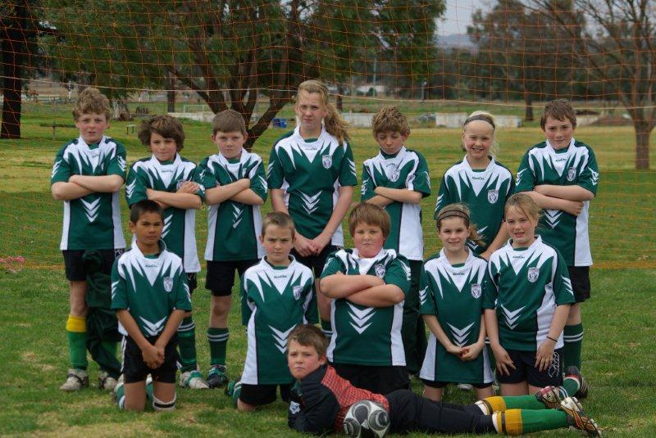

In secondary we have seen success at both an individual and team level and even though a small school we have managed to represent at a high level in a number of events:

* Open boys touch team narrowly missed out (in extra time) on making the centrals schools finals
* Jake Newman was selected to represent the western region athletics team in Discus at the state championships. Jake placed 2nd at western in discus and 3rd in the 400m
* Kyle Huppatz placed 3rd in 800m, 4th in Javelin and 4th in 200m at western athletics
* Michael Coleman placed 3rd in High Jump at Western Athletics
* Zac Guy and Tace Stevenson were selected in the zone U16s Rugby League team
* U16s Rugby League team finished 3rd in the region
* a narrow loss to Trundle in the Kadungle Cup.

Thank you once again to all the parents and community members who have contributed to sport this year. As you are well aware the students and I both appreciate it very much and every little bit counts. I look forward to yet another successful year with you all in 2011.

Other

Students participated in state and national competitions with great success. Daniel Walker achieved a distinction in science and credits in mathematics and English. Harry Patton achieved a credit in English. Kate Larkings and Harrison Jones both achieved a credit in computing.

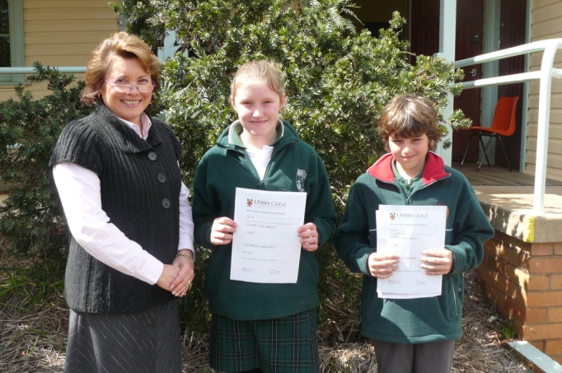

Students have continued to achieve great results in the Premiers Spelling Bee and Reading Challenge as well as Mathletics.

Academic

In the National Assessment Program, the results across the Years 3, 5, 7 and 9 literacy and numeracy assessments are reported on a scale from Band 1 to Band 10.

The achievement scale represents increasing levels of skills and understandings demonstrated in these assessments.

Yr 3: from Band 1 (lowest) to Band 6 (highest for Year 3)

Yr 5: from Band 3 (lowest) to Band 8 (highest for Year 5)

Yr 7: from Band 4 (lowest) to Band 9 (highest for Year 7)

Yr 9: from Band 5 (lowest) to Band 10 (highest for Year 9)

and/or

In the School Certificate the performance of students is reported in performance bands ranging from Performance Band 1 (lowest) to Performance Band 6 (highest).

Literacy – NAPLAN Year 3









Numeracy – NAPLAN Year 3



Literacy – NAPLAN Year 5









Numeracy – NAPLAN Year 5



Literacy – NAPLAN Year 7









Numeracy – NAPLAN Year 7



Literacy – NAPLAN Year 9









Numeracy – NAPLAN Year 9



Progress in literacy









Progress in numeracy



School Certificate













School Certificate relative performance comparison to Year 5 (value-adding)



Higher School Certificate

Due to there being only 3 HSC students there is no data for publication.

Data for the WAP program which includes Tullamore students taught by teachers at Tullamore and other WAP schools is provided in a separate annual report document for the WAP program.

Higher School Certificate relative performance comparison to School Certificate (value-adding)



Minimum standards

The Commonwealth Government sets minimum standards for reading, writing, grammar and punctuation, spelling and numeracy for Years 3, 5, 7 and 9.

The performance of the students in our school in the National Assessment Program – Literacy and Numeracy is compared to these minimum standards. The percentages of our students achieving at or above these standards are reported below.

Percentage of Year 3 students in our school achieving at or above the minimum standard in 2010



Percentage of Year 5 students in our school achieving at or above the minimum standard in 2010

 Percentage of Year 7 students in our school achieving at or above the minimum standard in 2010



Percentage of Year 9 students in our school achieving at or above the minimum standard in 2010



Significant programs and initiatives

Aboriginal education

Aboriginal education perspectives are integrated into the teaching and learning programs from K – 12. Complimenting this are specific aims integrated into school excursion programs. An AECG formation is planned for early 2011.

Multicultural education

Students studied other cultures in their class work as part of our Connected Outcome Groups (COGS) and Human Society and Its Environment (HSIE) lessons. Students also studied Scotland as part of the CWA Country of Study project and gave presentations to the CWA ladies. The students also had the opportunity to play the bagpipes and snare drum after a concert by Graham, Heather and Neville Jones.

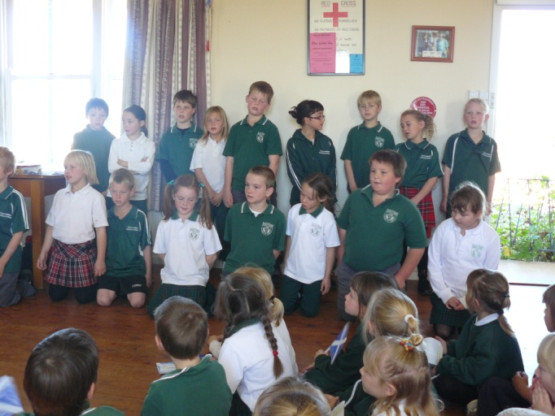

Respect and responsibility

Respect and responsibility are promoted through our PBL expectations, our school welfare policy, our SRC and the school chaplaincy and scripture programs.

Students earn the right to attend welfare barbecues at the end of each term and the annual welfare excursion through exemplary conduct.

Students are elected to the SRC each year using a formal electoral process.

National partnership programs

Tullamore Central School has been granted extra funding through the Low SES National Partnerships program, an initiative of the Federal Government. Our School Plan, which is on our website, indicates where our National Partnership funding is being spent and also our Country Area Program (CAP) funding. In 2010 we employed a Literacy teacher for 3 days per week to work with students to enhance their Literacy skills. Our Literacy teacher also worked with students and their teachers utilising the Lexia reading program which was also purchased with our National Partnership funding. Our National Partnership funding was also used to support the district employment of the Principal Mentor, Mr Craig Renneberg, and the Connected Learning Coach, Ms Pam Davis, who have come to our school and completed individual sessions for our staff in leadership development and utilising technology in the classroom. The Aboriginal Pedagogies facilitator who was supported through National Partnership funding, Dr Tyson Yunkaporta, presented the “8 Ways of Knowing” course that he developed with James Cook University at one of our Staff Development Days. This funding was used to help students in the classroom by employing Student Learning Support Officers in our K-10 classes.

Connected learning

Every classroom has an interactive white board (IWB) installed and they are fully utilized by class teachers.

Part of our CAP funding was used to train staff in blended learning and our National Partnership funding supported a Connected Learning coach to give staff individual and group lessons integrating technology into the classroom.

Other programs

**Country Area Program (CAP)**

Our CAP funding was used to provide opportunities for students to experience artistic, cultural and musical performances, hands on activities in the Questacon science shows and excursions to broaden their experiences.

The funding was also used to facilitate the continuing and expanding use of technology by teachers and students in the classroom including virtual excursions. Our Reading to Learn program was also continued with the support of CAP funding.

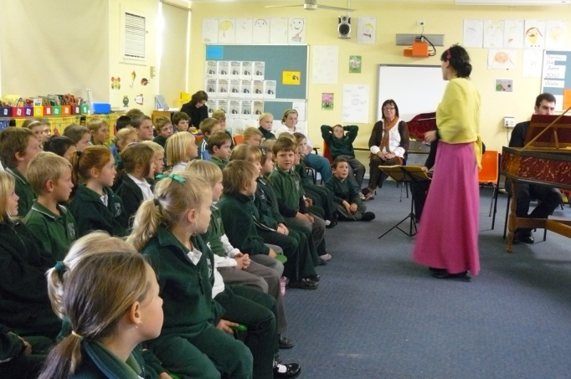

**Positive Behaviour for Learning**

Our PBL program was re-invigorated this year. Due to staff changes a new team was trained and the program developed to commence with lessons for the playground in 2011. At Tullamore Central School, our students are responsible, respectful, cooperative and honest learners. Thank you to Mrs Diane Darcy, our parent representative, and Ms Wanda Whitmill, our coach.

**Western Access Program**

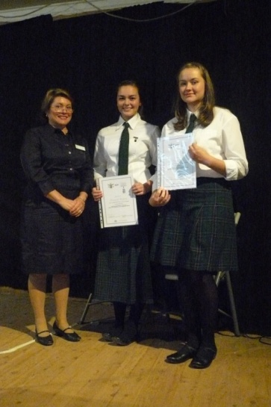The Western Access program offered over 55 subjects for students in Years 11 and 12. Students learn through a variety of connected learning media coordinated by the Course Coordinator who is a teacher in one of the Western Access Schools. The students are supported by a teacher in their home school and are able to attend study days with their cohort to revise, perform practical activities, field work and major works. Students attend a three day Access Camp at the beginning of each year to induct them into the program. Students are also supported with Work Placement for Vocational Education Courses by the WAP Workplace Coordinator, Mrs Christine O’Donoghue and the accommodation facilities at Dubbo School of Distance Education.

Progress on 2010 targets

The school will continue to focus on improving literacy and numeracy results across the school.

Target 1

Literacy Growth level comparable to state growth

Our achievements include:

* Years 3, 5, 7 and 9 literacy growth is below state level but has shown improvement
* Reading to Learn continued in primary classes
* Individualised reading programs with students from K – 10 with reading ages below chronological ages
* Buddy reading program across the school continued
* Introduction of Lexia program
* Literacy Growth level comparable to state growth

**Target 2**

***Growth in numeracy comparable to Regional Growth***

Our achievements include:

* Years 3, 5 and 7 numeracy growth is greater than regional growth however Year 9 numeracy growth is below regional growth
* Stage mathematic classes continued from K – 10
* Mathletics program continued.

Key evaluations

It is a requirement for all NSW public schools to conduct at least two annual evaluations – one related to educational and management practice and the other related to curriculum. In 2010 our school carried out evaluations of the Secondary Curriculum and the Student Welfare and Discipline Policy.

Educational and management practice

**Student Welfare and Discipline**

Background

As part of our self evaluation the school sought to know the opinion of staff, students and parents on our school welfare and discipline policy as concerns had been expressed by parents as to the fairness of the policy.

Findings and conclusions

All parents who responded to the survey said the school was a happy and safe learning environment. However, a small number expressed dissatisfaction that one or two students who continually disrupted the teaching of learning programs were not managed by the current policy.

Some staff felt that the expectations of student behavior were not promoted and understood by students and that older student behaviour was poor compared to the younger students.

Some staff indicated there had been inconsistencies in the application of discipline at the school however, this issue was not as apparent with the new executive at the school.

Some students indicated that not all teachers were consistent when it came to discipline as previously some students were given “special treatment”. However most students thought the system itself was fair except for the imbalance in the value of a ‘positive’ compared to a ‘negative’. That is, the students felt that one negative had to be counter balanced by three positives.

Future directions

The results of the survey were used to help modify the school welfare and discipline policy. The expectations of PBL were also written into the modified policy which will be taken to the P&C early in 2011 for ratification.

Curriculum

Secondary Curriculum

Background

Due to the decrease in student numbers in Years 9 – 12 a review of the secondary curriculum was undertaken.

Findings and conclusions

Parents indicated that they felt too much time was spent on elective subjects and not enough on the core subjects.

Parents also expressed a desire for agriculture, music and visual arts to have a higher profile within the school.

Parents indicated that the subjects offered to students in Years 11 and 12 through the WAP gave them choice and catered for the differing needs of their children.

Staff indicated that the curriculum was broad and allowed students opportunities to study the subjects they liked in Years 9 and 10.

Staff were very happy with the broad range of subjects that WAP offered and the opportunities they had to coordinate or co-teach these subjects.

Students expressed a desire to spend more time on their elective subjects and less time on the core subjects.

Students were very happy with the subjects offered by the school and WAP.

Future directions

Students in Year 9 were given the opportunity for early commencement of Stage 6 Vocational Education and Training subjects in Year 10.

Students will also be given the opportunity to achieve TAFE equivalent qualifications as part of their careers program in 2011 to enable students to be more employable in post school endeavours.

Other evaluations

Parent, student, and teacher satisfaction

In 2010 the school sought the opinions of parents, students and teachers about the school.

Their responses are presented below.

Parents were generally satisfied that Tullamore Central School provides a quality education for its students in a professional, caring, happy and safe environment. A third primary class was formed in 2010 and will be maintained in 2011, however the secondary numbers are still falling.

Parents use the school newsletter, P&C meetings, visits and phone calls to the school to seek information and clarification and to offer help and advice to the school

Professional learning

Staff participated in 5 staff development days in 2010. These focused on Blended Learning supported by CAP, Engagement and Memory Strategies with a presentation by Dr Rich Allan, integration of technology, Aboriginal pedagogies and PBL.

Other courses included First Aid and CPR, Asthma and Anaphylaxis, curriculum related workshops, early career teacher training and leadership.

School development 2009 – 2011

The school has continued the implementation of programs aimed at:

* Improving literacy and numeracy skills
* Increasing student engagement and retention
* Supporting initiatives in the area of Aboriginal education, and
* Quality teaching and connected learning.

Targets for 2011

Target 1

Increase the proportion of students in Years 3, 5, 7 and 9 achieving at or above minimum standards in writing, spelling, grammar and punctuation from 81% to 90% in 2011.

Strategies to achieve this target include:

* Develop K – 12 literacy policy and implement across the school
* Continue Lexia reading program
* Continue Reading to Learn
* Continue individual reading programs for students who need extra support.

Our success will be measured by:

* All teaching programs incorporate explicit writing strategies.
* Results in NAPLAN increase from 81% to 90% of students achieving at or above minimum standards
* Reading to Learn strategies utilized in class rooms.

**Target 2**

Increase the proportion of students in Years 3, 5, 7 and 9 achieving at or above minimum standard in numeracy from 72% in 2010 to 80% in 2011.

Strategies to achieve this target include:

* Implement Maths Matters from Kindergarten to Year 8.
* Continue Stage mathematics classes.

Our success will be measured by:

* Results in NAPLAN increase from 72% to 80% achieving minimum standard
* Maths Matters strategies being utilized in Kindergarten to Year 8 classes.

About this report

In preparing this report, the self-evaluation committee has gathered information from evaluations conducted during the year and analysed other information about the school's practices and student learning outcomes. The self-evaluation committee and school planning committee have determined targets for the school's future development.

Sandra Carter, Principal

Natasha Shankelton, Head Teacher Secondary Studies

Donna-lee Horsburgh, Assistant Principal

Bruce Jones, P&C President

Janette McCosker, Teacher Librarian

Vivienne Bolam, Support Teacher Learning Assistance

Cassie Richards, PDHPE teacher

Helen Clemens, School Administration Manager

School contact information

Tullamore Central School

Hinkler Street Tullamore NSW 2874

Ph: 02 6892 5005

Fax: 02 6892 5109

Email: tullamore-c.school@det.nsw.edu.au

Web: www.tullamore-c.schools.nsw.edu.au

School Code: 3270

Parents can find out more information about Annual School Reports, how to interpret information in the reports and have the opportunity to provide feedback about these reports at:

http://www.schools.nsw.edu.au/asr